

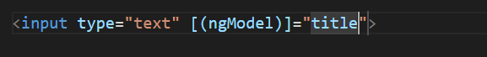

For using ngModel first we have to import it in module file like that



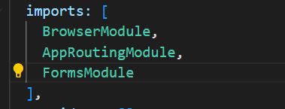

# To add Bootstrap

For adding bootstrap locally for the project





Then we add the path into angular.json in build (styles)

